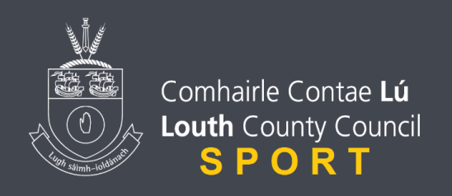
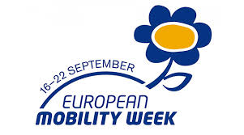

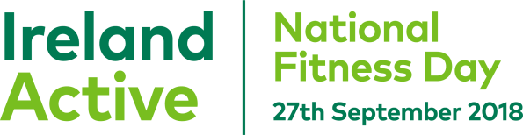
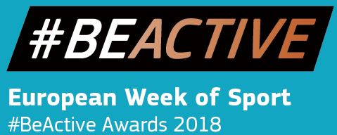

This is the list of events for European Week of Sport and National Fitness Day.

- Sunday 16th of Sept until Saturday 22nd Sept
European Mobility Week
The EUROPEANMOBILITYWEEK campaign provides the perfect opportunity to present sustainable mobility alternatives to local residents and to explain the challenges that cities and towns are facing. By taking part, towns and cities can showcase the benefits of cleaner transport choices and make progress towards better mobility in Europe.

- Saturday Sept 22nd
Stephen Carroll and Capt Mark Duffy Blackrock 4mile road race in Blackrock Village. You can sign up here. https://register.primoevents.com/ps/event/StephenCarrollCaptainMarkDuffy4MileRoadRaceFunRun2018

- Saturday 22nd Sept
The Tony Golden Charity Cycle takes place starting Blackrock
This year there is 3 different routes that will cater for all cyclists.
Route 1 - Cycle around the 13 Garda Stations in County Louth (165K),
Route 2 - Cycle around 3 Garda District Headquarter Stations (80K) Drogheda, Ardee and Dundalk
Route 3 - Cycle through each Garda District (40K)
The Passport Challenge Cycle is now closed to cyclists. All routes will begin and end at the Community Centre in Blackrock, Co. Louth.

- Saturday 22nd Sept
The Pulse Triathlon Club will be holding their annual Triathlon at Port Beach.
With a traditional beach swim start, and a bike leg on closed roads, this sprint distance race is perfect for both the newcomer to triathlon and the more experienced triathlete who is looking for a personal best.
For 2018, the Pulse Port Beach Triathlon will be a BMW Triathlon National Series and Triathlon Ireland Super Series event. For more information and to enter go to https://tinyurl.com/portbeach2018

- Thursday 27th Sept
As part of National Fitness Day there is a county wide challenge in local primary schools of the Teacher vs Pupils with a prize for the best pictures taken on the day of the challenge. Encourage children to get active.

- Thursday 27th Sept @ 7pm at Dundalk Sports Centre
The Hub will be launching the next Bootcamp Programme for the Autumn Season; this will be a free taster session bootcamp for all people to participate in. You can sign up to the full course on the night also and ask the programme coordinator Conor Gorham anything in relation to the programme.

