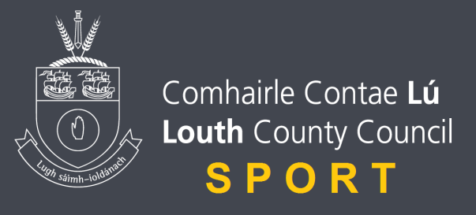

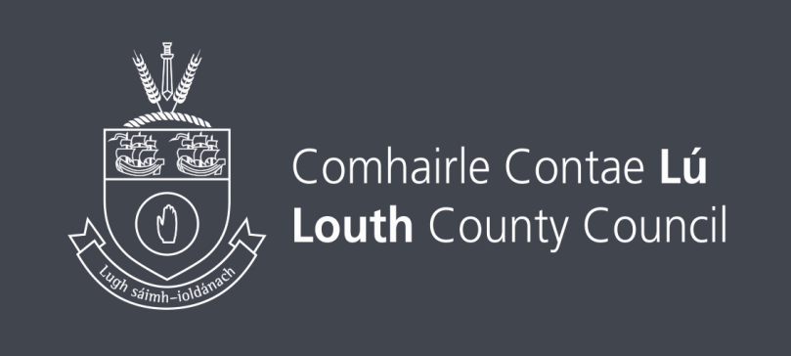
Louth Sports Unit Small Club Grant Scheme Guide

CONTENT
- INTRODUCTION
- WHO CAN APPLY
- WHAT WE WHAT TO FUND
- WHAT WE WILL NOT FUND
- PREPARING YOUR APPLICATION
- AFTER YOU HAVE APPLIED
- IF YOU ARE SUCCESSFUL

Introduction
Our small clubs grant scheme makes awards of up to €400 to not-for-profits organisations that can contribute to our strategic goals of:
- Increased participation in Sport and Physical Activity
- Greater access to training and education
- Better club Governance
The information in this guide will provide everything you need to know about the programme- but if you need any assistance please contact us on: 042-9324361. Or email at: gerard.mcgahey@louthcoco.ie
MAX one application per club.
Key Facts
- Value 2018-2019: €3,000
- Awards from: Up to €400
- Projects supporting our strategic goals
- Open to not- for -profit organisations

Who Can Apply
Before you consider applying for a grant, you need to be sure that your organisation and project are eligible for a small clubs grant award.
- Sports and Physical Activity Clubs based in the Louth area.
- Clubs must be affiliated to their National Governing Body of Sport where such an NGB exists.
- Clubs must also be run on a not for profit basis.
- Joint applications from sports clubs will be favourably considered.

We will not fund an individual, a sole trader or partnership, organisations established to make profit or organisations not established in Louth area.
- If your organisation is a branch of a larger organisation , you should confirm that you are independent of them before you apply.
- If you don’t have your own committee, bank account and club constitution, you will need the support of your parent organisation, which must accept overall responsibility for the award.

What We Want to Fund
Our Strategy sets out our vision for developing Sport in Louth.
We want everyone in Louth regardless of age, background or level of ability to feel able to engage in sport and physical activity. Some will be young, fit and talented, but most will not. We aim to develop a sports sector that welcomes everyone, meets their needs, treats them as individuals and values them.
We want fund eligible organisations that get more people engaged in sport and meet one or more of our strategic goals:
- Increased participations in Sport and Physical Activity
- Greater Access to Training and Education
- Better club Governance

Your Project must also:
- Request a sum up to €500 and
- Be deliverable within a 12 month period from the date of our award letter

What We Will Not Fund:
The focus of the project should be the problem you are trying to solve and the difference that our funding will make -not what you need to buy to make that difference happen.
THERE ARE SOME COSTS THAT WE WILL NOT FUND
- Ongoing running costs of clubs – hall hire, prizes, transport, coaching fees relating to normal club activities, registration/affiliation fees, insurance, general administration costs
- Payment of debt
- Catering/Refreshments costs
- Local Sports Partnership courses – these are already subsidised
- Sports Clothing
- Programmes that are not in line with the goal of increasing and sustaining participation in sport and physical activity
- Capital Costs
- Fixed items of equipment. This may include goals and nets that cannot be easily removed. We also cannot fund fixed equipment which may require planning permission or may impact on any lease.
- Projects that take place or incur costs before the date of offer letter. This includes any form of deposits and costs associated in submitting the application.
- Projects outside of Louth eircode.

Demonstrating Best Value
For any purchase, such as hiring of coaches or buying equipment, we encourage you to get prices from a selection of suppliers to ensure you are getting best possible price.

Funding for Equipment
Our grant scheme can fund equipment that will help you get people active and playing sport- but your application should focus on the difference the equipment makes. We view equipment as a means to achieving an outcome, so any application for equipment should explain why it is needed to deliver that outcome.

We are unlikely to fund any equipment that replaces items you either currently have or have access to within the last five years. We could potentially fund an upgrade to an existing piece of equipment if it enables additional outcomes too be delivered. For example if your team progresses to a higher league and it requires you have a certain piece of equipment in Place.
Preparing your application:
THERE ARE VARIOUS ASPECTS TO CONSIDER WHEN PREPARING YOUR APPLICATION, INCLUDING GATHERING THE RELEVANT SUPPORTING DOCUMENTS AND REGISTERING YOUR ORGANISATION
When you have checked that your organisation is eligible to apply and your project meets our funding criteria, you should consider the following steps:

- Plan your project
- Gather your information
PLAN YOUR PROJECT
Grant Applications are more likely to be successful if they can show the project has been carefully thought through. We will assess your application against four key questions, so you should consider whether:
- You understand why the project is needed
- You know what impact your project will have. For example, the number of people who will benefit and the number of times they will take part
- You know how you will deliver the project and measure its success
- You can sustain the benefit of the project beyond the life of the grant

- Complete your application
GATHER YOUR SUPPORTING DOCUMENTS
For non-statutory organisations, you will need to include copies of the following with your application:
- Governing document/constitution
- Most recent annual income and expenditure accounts.
- Last three months of bank statements – if you are a new organisation, please provide evidence that you have a bank account
- Safeguarding Policies (if relevant to your project) These documents should all be in the name of your organisation.,

Complete your application
We are looking for the best projects, not the best applications, and you should only write something you think really helps us understand how good your project is. To help successfully present your project, please consider the following questions:
- What problem you are trying to solve?
- How do you know your particular project is needed by those you want to attract? Have you undertaken any consultation with them?
- What difference will your project make?
- What will be the impact?
- How will you deliver your project? Can you simply explain the steps to achieving the impact you want to achieve? You may find a simple delivery plan helps with this but it is not a requirement
- Does your organisation have the right skills and experience to deliver the project? If not, who will you work with to help?
- Will you be able to measure the results of your project? You will need to report on the success of your project if we provide funding, so you should consider how you will be able to do this
- How will you ensure there is a lasting benefit from the project? Can you explain how you will either sustain the activity after our funding period finishes or how the outcomes achieved will be sustained if you do not plan to continue the activity?

After you have applied:
ONCE YOU HAVE SUBMITTED YOUR APPLICATION, WE WILL CHECK IT IS COMPLETE AND THAT YOU HAVE SENT ALL THE SUPPORTING DOCUMENTS WE NEED.
If anything is missing or we need some further information, we will contact you to request it. Once everything is in place, we will assess your application. We do this in two stages. The first is to check if your organisation and project are eligible for funding. If it is not, unfortunately we will not consider the quality of your project further. For all eligible projects, we aim to provide a funding decision as quickly as possible. Usually this takes no more than eight weeks from the date you submit your application.
Please be aware that our Small Grants programme has limited funds and we sometimes have to turn down eligible and potentially fundable projects simply because we don’t enough money to support everything we would like to. If we don’t fund your project, we will provide written feedback to you.

If you are successful:
ONCE YOU HAVE SUBMITTED YOUR APPLICATION, WE WILL CHECK IT IS COMPLETE AND THAT YOU HAVE SENT ALL THE SUPPORTING DOCUMENTS WE NEED.
If anything is missing or we need some further information, we will contact you to request it. Once everything is in place, we will assess your application. We do this in two stages. The first is to check if your organisation and project are eligible for funding. If it is not, unfortunately we will not consider the quality of your project further. For all eligible projects, we aim to provide a funding decision as quickly as possible. Usually this takes no more than eight weeks from the date you submit your application.
Please be aware that our Small Grants programme has limited funds and we sometimes have to turn down eligible and potentially fundable projects simply because we don’t enough money to support everything we would like to. If we don’t fund your project, we will provide written feedback to you. There may be incidents we will fund aspects of the project rather than project as a whole.

IF YOU ARE OFFERED A GRANT, YOU WILL RECEIVE ANA GRANT AGREEMENT THAT STATES THE PURPOSE OF THE GRANT AND CONTAINS OUR TERMS AND CONDITIONS
It will also contain various forms that you will need to fill in to accept and claim your award. Please read your award letter carefully and keep it safe for future reference.
Your grant is intended specifically for the project you have applied for, and any proposed changes should be discussed with us in advance. You should pay particular attention to keeping all receipts and evidences of expenditure. Payments for goods and services for the project should be made, wherever possible, from the organisation’s bank account as we may request bank statements to verify claims for payment.
CONTACT US If you are unsure of anything in this guide or need any other information, please call us on: 042-9324361 or email at: gerard.mcgahey@louthcoco.ie.

