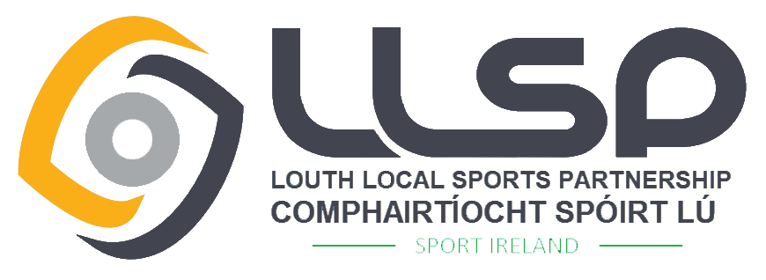
Louth Local Sports Partnership
Small Club Grant 2020
Criteria
Louth Sports Partnership aims to support volunteers and develop opportunities for people to participate in organised sport. This small scale grant aims to support initiatives to increase participation levels of Disability, Mental Health, Triathlon, Volleyball, Basketball, Tennis, Lawn Bowls, Disadvantaged Communities, Ethnics Minorities and Unemployed. Proposed initiative should attract new members and ideally enhance ongoing participation. This grant also supports the set up of new clubs for these target groups/sports and assists existing clubs with initiative to increase participation. Maximum Grant Awarded - €1,000.
Closing Date: Wednesday 5th February 2020 at 4pm

GRANT OVERVIEW
Who can apply? – To be eligible clubs / sporting organisations must:
- Be based in the Louth area and be affiliated to a Sport Ireland recognised NGB or disability organisation.
- Operate as a not for profit group and be open for public membership.
- Have policies and practices that encourage participation regardless of gender, age, race or ability.
- Clubs must operate the best practice for Children in Sport – a member of the club must have previously attended a Child Welfare & Protection Awareness Course.
- Must be registered with Louth PPN. (Call Jeanette Morgan 042-9324284)
- Only one application per club.

Who can not apply?
- Individuals, Schools, Capital Projects.
- Older / Active Age Community Groups & Agencies (Go For Life Programme).
- Projects that are fundable from another source.
- Commercial Organisations, for profit groups.
- County / Regional / National Organisations or Statutory Agencies.

What we want to fund:
- New Clubs – Set up costs for clubs established in the last 2 years e.g. bibs, cones, training equipment.
- Existing Clubs – Set up costs for initiative to increase participant numbers of an existing or new branch of the club or increase physical activity targeting Disability, Mental Health, Triathlon, Volleyball, Basketball, Tennis, Lawn Bowls, Disadvantaged Communities, Ethnics Minorities and Unemployed.
- Coaching Fees – Fees for coaching/referee courses accredited by Coaching Ireland or a National Governing Body of Sport to support the proposed participation in initiative.

What we will not fund:
- Ongoing running costs of clubs – hall hire, prizes, transport, coaching fees relating to normal club activities, registration/affiliation fees, insurance, general administration costs.
- Payment of Debt or Loans
- Local Sports Partnership Courses – these are already subsidised.
- Sports Clothing – e.g. individual clothing or team kit.
- Capital Costs.
- Courses outside of Ireland or uncertifiable courses.
- Projects that take place or incur costs before the date of offer letter.

Application Process:
- The Application Form must be completed in full and signed by the Club Chairperson and Treasurer
- The form must be legible and provide clear information with detailed costs breakdown.
- Application Forms must be returned with the supporting information requested e.g. Constitution / Club Rules and Copy of most recent accounts (3 months).
- Applications must be submitted by the deadline – Wednesday 5th February 2020 at 4pm.
- The Louth Sports Partnership Sub Committee will review all applications within 6-8 weeks of the closing date of the Grant Scheme and all applicants will be notified of the decision of the committee.
If you are successful:
- Successful applicants will receive a grant agreement that will outline the purpose of the grant. (Maximum grant awarded will be €1,000)
- Successful applicants will be required to submit a report after the event/programme along with receipts in order to recoup the final payment of the grant.
- Successful applicants must recognise the support of Louth Sports Partnership and comply with any reasonable request regarding publicity surrounding their project.

For general information, contact Alan Minto on 042-9392986 or alan.minto@louthcoco.ie alternative you can contact the following:
Disability & Mental Health | Triathlon, Volleyball, Basketball, Tennis, Lawn Bowls | Disadvantaged Communities, Ethnic Minorities, Unemployed
Triona Faapito  085-1110804  Triona.faapito@louthcoco.ie | Barry Casey  087-7067489  Barry.casey@louthcoco.ie | Graham Russell  042-9324368  Graham.russell@louthcoco.ie

Completed application forms should be returned by 4.00pm on Wednesday 5th February 2020

Return Postal Address:
Sports Club Grant Application, Louth Sports Unit, Dundalk Sports Centre,
Tom Bellew Avenue, Dundalk, Co. Louth, A91 X36T

PLEASE NOTE – Applications received after the closing date will not be considered

THE DECISION OF THE COMMITTEE IS FINAL

