Sports Leadership Registration Consent Form for Course 6th, 7th, 8th & 9th April 2020
(Please fill in block Capitals)
Participants Name
Date of Birth
Postal Address
Email Address
Contact Phone Number
Club/Organisation

I, ___________________(your name), am committed to participating in the Sports Leadership Awards programme.

Participants signature: _________________________ Date: ____________________

Parental/Guardian Consent:

Please Circle the word Give or Not give

- I give/do not give my permission for ________________ (name of child) to participate in the Sports Leadership Award

Please Circle the word Give or Not give

- I give/do not give my permission for ________________ (name of child) to be photographed for the assessment portfolio to be verified by sports leaders UK and may be used on our website, facebook page and in Louth local Sports partnerships publications or promotional material.

Parent/guardian name (Print): ___________________________

Parent/guardian Signature: _____________________________

Phone No: _________________________

Date: _____________________________

Places limited to 4 per club, any more will be added to waiting list.

Please return this completed signed form to: Louth Local Sports Partnership, Dundalk Sports Centre, Tom Bellew Avenue, Dundalk, Co. Louth or you could also email a scanned signed copy to alan.minto@louthcoco.ie by 30th of March 2020.
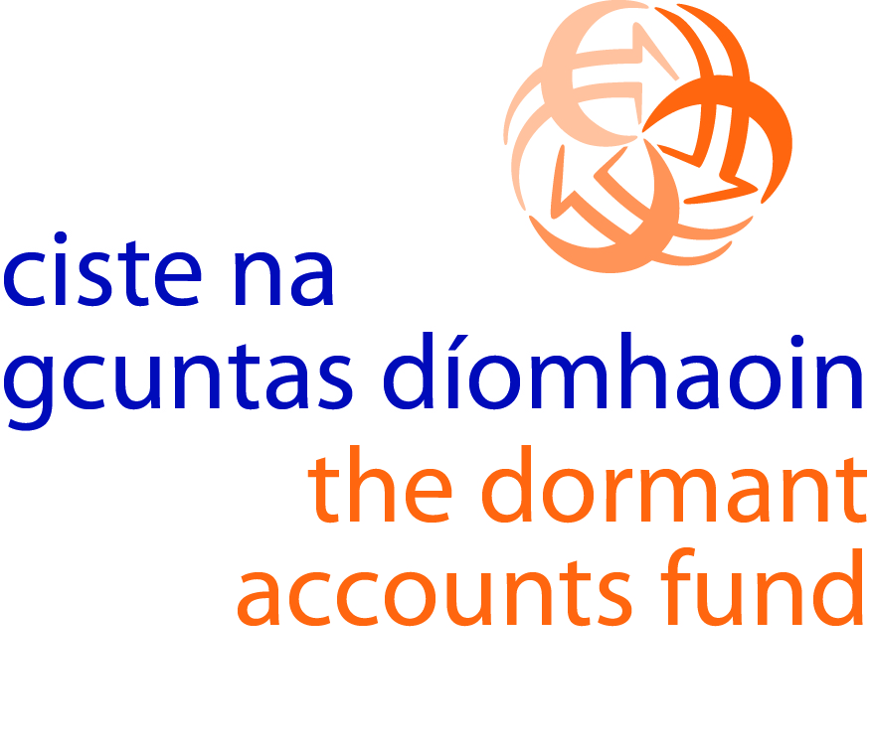
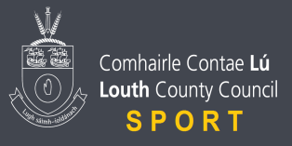
Please phone 042-9392986 to arrange payment of €30.00 fee.

