Online Coaching Children programme

Expression of interest

Closing date for return of expressions of interest

Tuesday 16th November@ 4pm
Please note:
Places are limited – shortlisting may occur
Applicants must be over 18 years of age

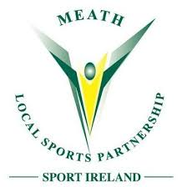

Personal Details

Name
Address

Email
Phone
Club
Role(s) in club
List coaching awards/ certs
(if any)

Qualifying criteria

Are you practising as a coach / mentor with your club? | YES/NO
How many years have you been coaching?

Is your club registered to a Sport Ireland affiliated National Governing Body?  If yes, please provide the name of this affiliated body e.g. GAA, IRFU, FAI etc. | YES/NO
Have you completed Child Safeguarding 1  Please provide certificate number  Please provide date of completion | YES/ NO
Have you completed Garda Vetting through your club  (If selected you will be required to provide proof of clearance letter) | YES/NO

Email your completed form to aine.mcdonald@louthcoco.ie
