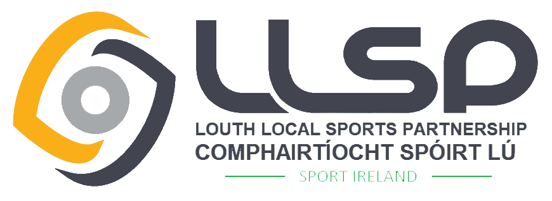
Louth Local Sports Partnership
Small Club Grant 2023
Criteria
Louth Sports Partnership aims to support volunteers and develop opportunities for people to participate in organised sport. This small scale grant aims to support initiatives to increase participation levels in Sport & Physical Activity. Proposed initiatives should attract new members and ideally enhance ongoing participation. This grant also supports the set up of new clubs and assists existing clubs with initiatives to increase participation. Maximum Grant Awarded - €1,500.
Closing Date: 12th April 2023 at 4pm

GRANT OVERVIEW
Who can apply? – To be eligible clubs / sporting organisations must:
- Be based in the Louth area and be affiliated to a Sport Ireland recognised NGB or disability organisation.
- Operate as a not for profit group and be open for public membership.
- Have policies and practices in place that encourage participation regardless of gender, age, race or ability.
- Clubs must operate the best practice for Children in Sport – Club members/Volunteers must have completed a Child Welfare & Protection Awareness Course.
- Must be registered with Louth PPN or register at www.louthppn.ie
- Only ONE application per club.
- Have adequate insurance in place covering the activities for which funding is to be used.
- Where applicable, sports clubs that received previous funding from Louth Sports Partnership, must have fully drawn down all funds to be considered for new funding.
- Due to late launch of 2022 grant, clubs that secured funding in 2022 can apply for 2023 funding but cannot draw down the 1st instalment until the 2022 grant is completed including receipts and reports returned to Louth Sports Partnership.

Who can not apply?
- Individuals, Schools, Capital Projects.
- Projects that are funded by another source.
- Commercial Organisations, for profit groups.
- County / Regional / National Organisations or Statutory Agencies.

What we want to fund:
- New Clubs – Set up costs for clubs established in the last 2 years e.g. bibs, cones, training equipment, team kit (LSP branding guidelines will be issued if applying for team kit, LLSP Logo must be front and centre on all jerseys).
- Existing Clubs – Set up costs for initiatives to increase participant numbers of an existing or new branch of the club or increase physical activity targeting Disability, Mental Health, Disadvantaged Communities, Ethnics Minorities, Unemployed, Youth, Women & Girls, Older Adults and Men 35+.
- Better Governance - Governance & Committee capacity building initiatives.

What we will not fund:
- Ongoing running costs of clubs – hall hire, prizes, transport, coaching fees relating to normal club activities, registration/affiliation fees, insurance, general administration costs.
- Payment of Debt or Loans
- Local Sports Partnership Courses – these are already subsidised.
- Sports Clothing – e.g. individual clothing, tracksuits (other than Team Kit which must follow LSP branding guidelines).
- Capital Costs.
- Courses outside of Ireland or uncertifiable courses.

NOTE:

- We will not accept applications for events/programmes that have already taken place.
Application Process:
- The Application Form must be completed in full and for Hard Copy Forms to be signed by the Club Chairperson and Treasurer. For online application forms, declaration must be agreed by senior club member and details of same given.
- The form must be legible and provide clear information with detailed costs breakdown.
- Application Forms must be returned with the supporting information available if requested e.g. Constitution / Club Rules and Copy of most recent accounts (3 months).
- Applications must be submitted by the deadline – Friday ???? at 4pm
- The Louth Sports Partnership Sub Committee will review all applications within 1-3 weeks of the closing date of the Grant Scheme and all applicants will be notified of the decision of the committee.
If you are successful:
- Successful applicants will receive a grant agreement that will outline the purpose of the grant. (Maximum grant awarded will be €1,500) 80% payment will be made on acceptance of the terms.
- Successful applicants will be required to submit a report after the event/programme along with receipts in order to recoup the final 20% payment of the grant.
- Successful applicants must recognise the support of Louth Sports Partnership and comply with any reasonable request regarding publicity surrounding their project.
For general information, contact Áine McDonald on aine.mcdonald@louthcoco.ie
OR
042-9324318 Monday – Friday 10am – 4pm.

Completed application forms should be returned by Wednesday 12th April 2023 at 4pm

Return Postal Address:
Sports Club Grant Application, Louth Sports Unit, Dundalk Sports Centre,
Tom Bellew Avenue, Dundalk, Co. Louth, A91 X36T

PLEASE NOTE – Applications received after the closing date will not be considered

THE DECISION OF THE COMMITTEE IS FINAL

